**OBJECTIVES:**

* To study Diodes.
* To study different diode configurations.
* To study forward and reverse biasing of diodes.

**DIODES:**

***“A diode is an electrical component having two terminals that exclusively conducts current in one direction (so long as it is operated within a specified voltage level).”***

In one direction, an ideal diode will have zero resistance, while in the other, it will have infinite resistance.

In the real world, however, a diode will have very low resistance in one direction (to allow current flow) and very high resistance in the other (to prevent current flow). A diode is an electrical circuit's equivalent of a valve.

**Forward Biased:**

When current flows in this direction, the diode is said to be "forward biased."

**Reverse Biased:**

The diode is considered to be "reverse biased" when it is linked in the opposite direction (i.e. the "high resistance" direction) within a circuit.

**Diode Symbol:**

The arrowhead points in the direction of conventional current flow in the forward biased condition. That means the anode is connected to the p side and the cathode is connected to the n side.

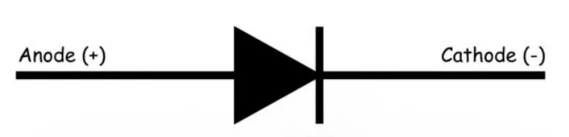

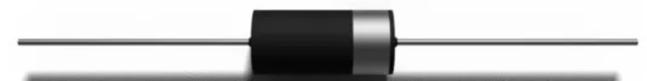

***Figure 1.1 Diode***

**Construction:**

We can make a simple PN junction diode by doping pentavalent or donor impurity in one area of a silicon or germanium crystal block and trivalent or acceptor impurity in the other.

In the middle of the block, these dopings form a PN junction. A PN junction can also be created by using a unique fabrication technique to link a p-type and n-type semiconductor together. The anode is the terminal that is attached to the p-type. The cathode is the terminal connecting to the n-type side.

**Working:**

The interaction between n-type and p-type semiconductors is essential to the operation of a diode. An n-type semiconductor is characterized by a large number of free electrons and a small number of holes. In other words, in an n-type semiconductor, the concentration of free electrons is large while the concentration of holes is quite low.

The majority charge carriers in an n-type semiconductor are free electrons, and the minority charge carriers are holes in an n-type semiconductor.

A p-type semiconductor contains a large number of holes and a small number of free electrons. In a p-type semiconductor, holes are the majority charge carriers, whereas free electrons are the minority charge carriers.

**Forward:**

If the positive terminal of a source is connected to the p-type side of the diode and the negative terminal is linked to the n-type side, and the voltage of this source is gradually increased from zero.

There is no current going through the diode at first. This is because, despite the fact that an external electrical field is provided across the diode, the majority of charge carriers do not receive enough external field impact to pass the depletion area. The depletion area, as previously stated, acts as a potential barrier to the majority of charge carriers.

This possible stumbling block is known as the forward potential significant barrier. Only when the value of externally applied voltage across the junction exceeds the potential of the forward potential barrier do the bulk of charge carriers begin to pass the forward potential barrier. The forward barrier potential of silicon diodes is 0.7 volts, while that of germanium diodes is 0.3 volts.

When the forward voltage supplied across the diode exceeds the forward barrier potential, the free majority charge carriers begin to penetrate the barrier and contribute to the forward diode current. In that case, the diode acts as a short-circuited route, and the forward current is limited solely by the diode's externally attached resistors.

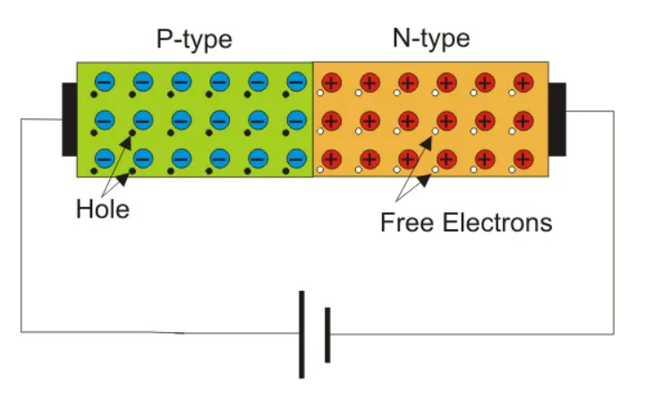

**Reverse:**

If we connect the voltage source's negative terminal to the p-type side of the diode and the positive terminal to the n-type side, the diode will be p-type. Due to the negative potential of the source's electrostatic pull, the holes in the p-type region would be moved further away from the junction, leaving more exposed negative ions near the junction.

Similarly, free electrons in the n-type area would be moved away from the junction and towards the voltage source's positive terminal, leaving more exposed positive ions in the junction.

The depletion region widens as a result of this occurrence. The reverse biassed condition of a diode is what it's termed. At that point, no majority carriers cross the intersection; instead, they move away from it. When a diode is reverse biassed, it prevents current flow in this way.

In a p-type semiconductor, there are always some free electrons, and in an n-type semiconductor, there are always some holes. Minority charge carriers are the charge carriers in a semiconductor that are opposing each other.

Because the field across the depletion region is not present in the reverse biassed condition, the holes on the n-type side can readily cross the depletion region.

As a result, a small current flows from the positive to the negative side of the diode. Because the number of minority charge carriers in the diode is so small, the amplitude of this current is quite minimal. Reverse saturation current is the name for this type of current.

When the reverse voltage across a diode is elevated beyond a safe level, a number of covalent bonds are broken, resulting in a large number of free electron-hole pairs in the diode.

The diode's reverse current would be enormous due to the large number of produced charge carriers. The diode may be irreversibly destroyed if the current is not limited by an external resistance linked to the diode circuit.

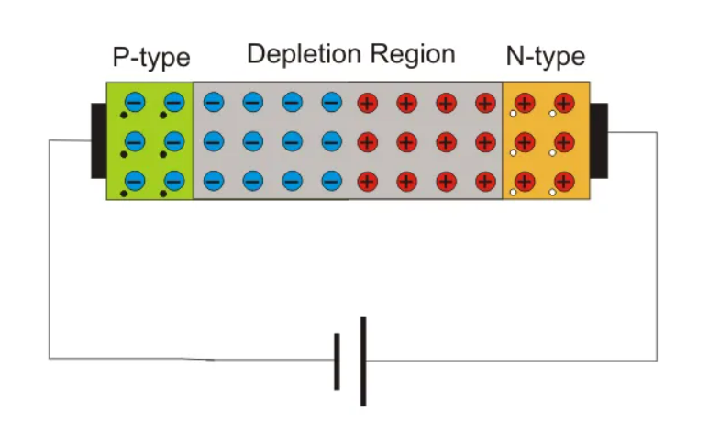

**EXPERIMENT:**

Now we perform an experiment to prove the forward and reverse biasing of the diodes.

**Components:**

* 1N4007 Diode
* Generic Resistor(1k and 10k)
* Generic variable resistor(POT)
* Ammeter
* Voltmeter
* AA119 Diode

**Circuit:**

**Forward Bias:**

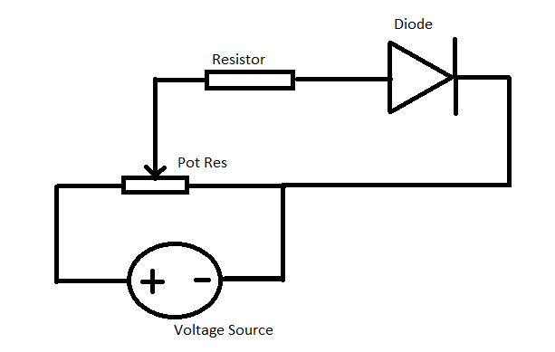

* Connect the circuit as shown in the figure above.
* Take Resistor as 1k
* Voltage as 25V

**Reverse Bias:**

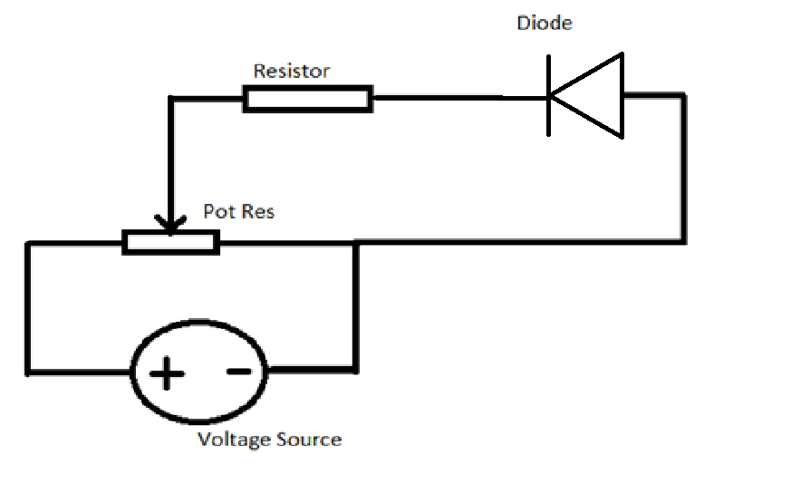

* Connect the circuit as shown in the figure above.
* Take Resistor as 1M
* Voltage as 25V

**Working:**

Slowly turn the knob of variable resistor and record the values of Voltage across diode and the current flow.

**Observations: (Proteus)**

Following are the observations taken on simulation software proteus.

**Silicon Diode:**

For silicon diode,

**Forward Biased:**

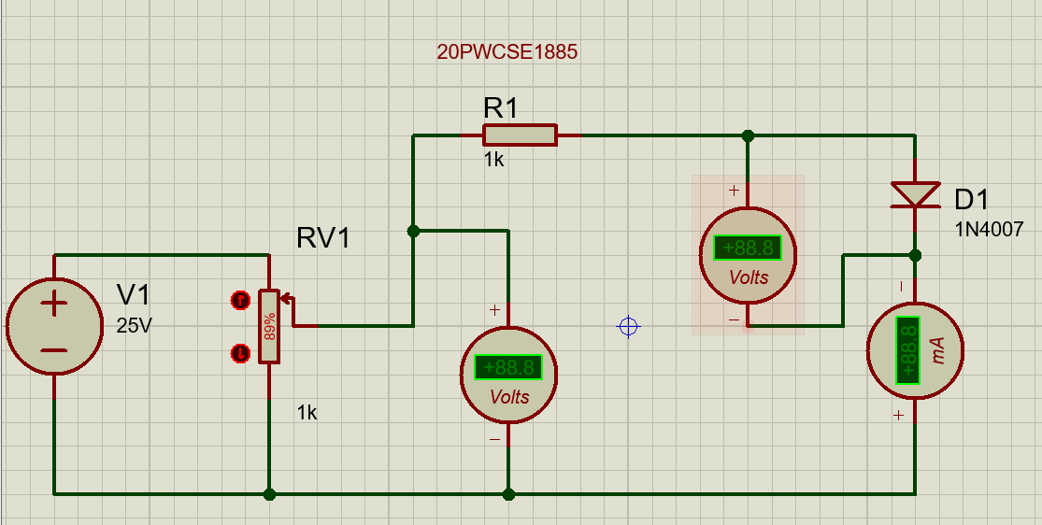

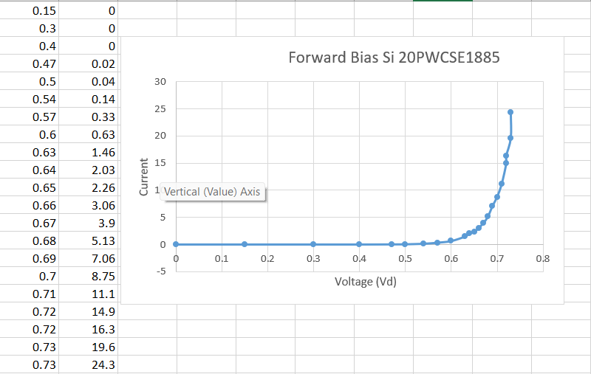

**Reverse Biased:**

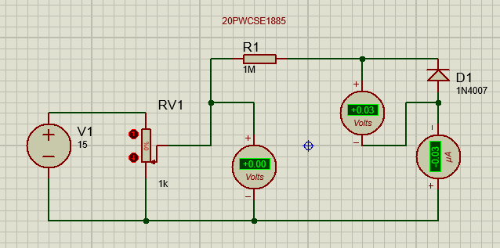

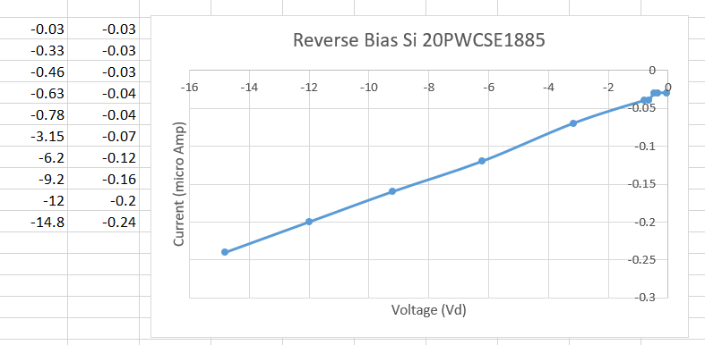

**Germanium Diode:**

For Germanium diode,

**Forward Biased:**

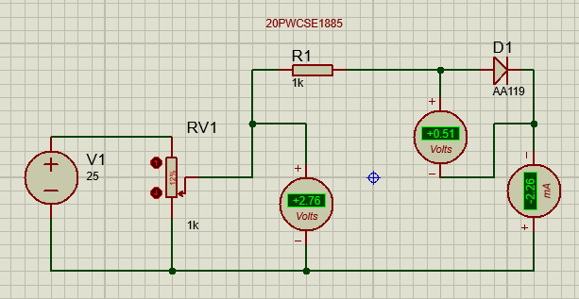

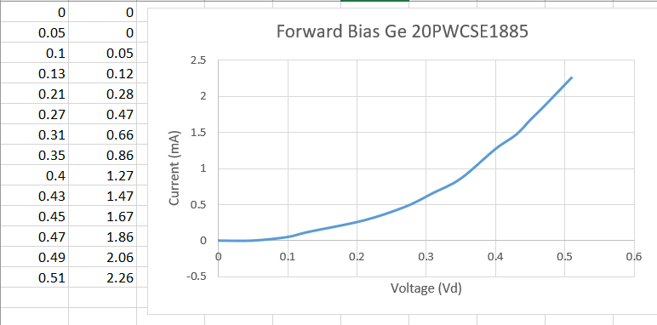

**Reverse Biased:**

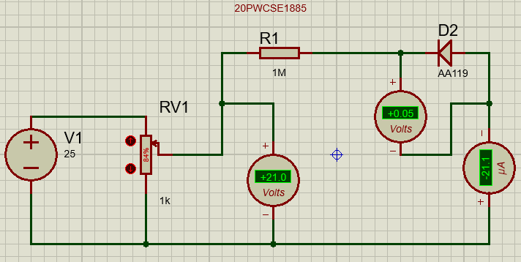

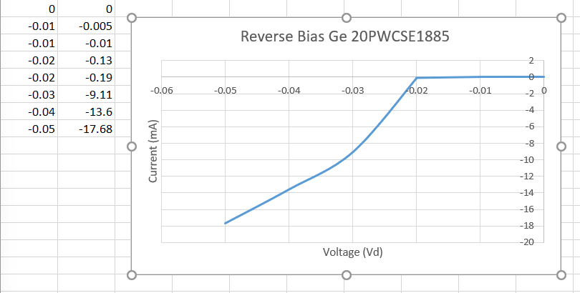

**OBSERVATIONS: (Practical)**

The observations recorded through hands on experiment in Lab are;

|  |  |
| --- | --- |
| **Forward Bias** | |
| **Vd** | **Id** |
| 0.7 V | 20 mA |
| 0.74 V | 40 mA |
| **Reverse Bias** | |
| **Vd** | **Id** |
| 9.94 V | 0.1 microAmp |
| 13.32 V | 4.4 microAmp |